 | PROPAGATION OF ORNAMENTAL PLANTS  Editorial Office, University of Forestry, 10 Kliment Ohridski blvd.,  Sofia 1756, Bulgaria, Fax: (++ 359 2) 862 28 30, e-mail: ivilievltu@yahoo.com,  www.journal-pop.org

CHECKLIST FOR REVIEWERS

Title of the manuscript: In vitro responses of trifoliate orange to directly and gradually increasing external NaCl concentration

Author (s): Christos Chatzissavvidis, Chrysovalantou Antonopoulou, Ioannis Therios and Kortessa Dimassi

No of the manuscript: JPOP717…

Deadline for the receiving of your review: 30 days after the receiving of the manuscript

Please consider main points A and B. Please DO NOT CONTINUE TO REVIEW the manuscript if:
- the answer to point A.1 is NO
- the answer to point A.2 is YES
- the answer to point B is LOW.

A. Relevance of the paper.

1. Is the subject of the manuscript within scope of the journal?
□ Yes
√ No

2. Previous publication of the material
√ No
□ Yes. What and where………………………………………………………………...
…………………………………………………………………………………………..

B. Scientific and practical importance of the data

□ High
□ Adequate
√ Low – See comments

C. Scientific quality

1. Are the data in this manuscript new?
□ Yes
□ No. Comments:…………………………………………………………………………

2. Is the manuscript clearly written and well-organized?
□ Yes
□ No. Comments:…………………………………………………………………………

3. Are the Abstract and the Key words adequate?
□ Yes
□ No. Suggestions:…………………………………………………………………………

4. Does the Introduction state the aim of the research and present knowledge?
□ Yes
□ No. Comments:…………………………………………………………………………

5. Materials, methods and study design
□ Adequate
□ Improvement needed. Suggestions:………………………………………………
□ Inadequate. Comments:…………………………………………………………

6. Results and Discussion
□ Properly drawn with regard to methods and data
□ Should be adjusted – Suggestions: ………………………………………………….
…………………………………………………………………………………………..
□ Insufficiently supported – Comments: ……………………………………………..
………………………………………………………………………………………….

7. Are the tables and figures titles and legends presented well and necessary?
□ Yes
□ Improvement needed. Suggestions:……………………………………………………
□ No. Comments:…………………………………………………………………………

8. Data and statistical treatment
□ Adequate
□ Improvement needed. Comments:……………………………………………………
□ Inadequate. Comments:………………………………………………………………

9. Have all relevant literature been cited
□ Yes
□ No. Suggestions:…………………………………………………………………….

E. Recommendations (after corrections)
□ The paper should be published as it is now, or with minor editorial changes
□ The paper could be published after minor revision, and need not be re-reviewed
□ The paper could be accepted after major revision according to the comments
√ Rejected

If adjustments or revision is recommended
□ The writer is allowed to contact me (sign both copies of this checklist)
√ I want to be anonymous (sign only one copy of this checklist)
□ I am not willing to review this paper again (revision)

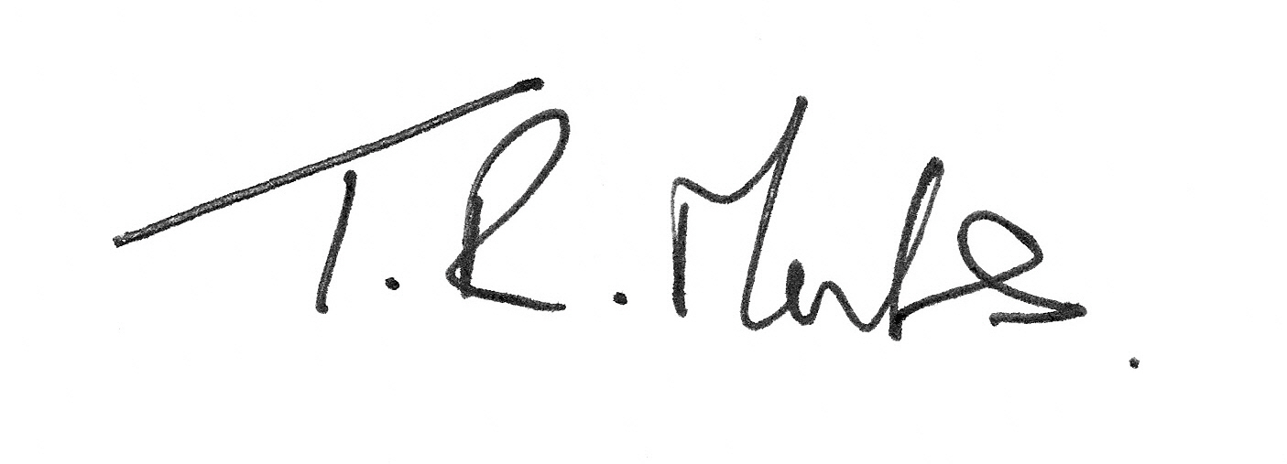
23rd May 2013

Please add further comments.
- Poncirus is primarily used as a rootstock in the horticultural production of fruit and little has been presented to put it into an ornamental context.
- Very little information is given in the Introduction to justify the study, what previous work has gone before and anything about using this approach for in vitro selection. Often findings can be difficult to translate to whole plant physiology.
- The data is only interpreted as comparisons with other authors’ data, or as trends in the presented data; but with little understanding or explanation of what is causing the effects.
- Data may have been better presented graphically. Differences between the direct and gradual applications may have been both easier to see and interpret. However, the methodology is unclear as to what data is presented for the gradual sodium chloride application; it seems to imply that data was collected after each one week subculture, but only one set of data is presented (after six weeks?). This is unclear as it also implies that transfers were to the same concentration of salt, and hence not a gradual increase!
- Suggestion that response to gradual application is interesting may be true, but nothing to explain why. Just to say that the treatments imposed led to significant alterations in growth is inadequate for a scientific paper.
- That some measured parameters show inconsistencies in trends may be due to variables in the tissues used, or in procedures involved, and requires explanation.

